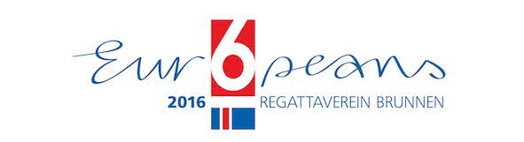

Sailing

European Championship 2016 of the 6 Metre JI Class in Brunnen, Switzerland
Gorgeous weather for sailors
Brunnen, 18th of July 2016 - Lots of sun and first grade wind conditions accompanied the European Championship so far.

Over the last few days the 31 crews who were registered for the Swiss International 6 Metre Class Championship did not have much to cheer about. Constant rain and almost no wind greeted the sailors every day. But since the start of the European Championship the Lake of Lucerne presented itself from its very best side. Since Saturday the sailors were greeted with plenty of sunshine and winds between 8 and 16 knots. Race officer Martin Kolb was very pleased: "Everything worked out smoothly. And most important: The sailors finally got to enjoy the legendary wind the region is known for“.

Until Monday evening 6 races could be completed, thus this years European Championship is on schedule. According to the international class rules, a minimum of four races is needed for the European Championship to constitute. The same rule applies to the Swiss Class Championship, which took place in the previous week in Brunnen as well, but fell through due to lack of wind.

Swiss still in the lead in the „Moderns“ Group
The Europeans are carried out in two categories: the „Classics“ for Yachts built before 1956 and the „Moderns“. In the later Swiss Skipper Jean-Luc Monnard on „Junior“ still sits in a comfortable lead. Also position 2 and 3 remained unchanged. US boat „Sting“ with Russ Siilvestri at the helm and „Valhalla“ from Great Britain with Skipper Paul Smith managed to defend their positions.

New leader in the „Classics“ Group
In the „Classic“ category, the second placed „Nada“ from Great Britain with Skipper Poul Hoj-Jensen moved up to first place today, pushing US competitor „Lianoria“ with Eric Jesperen at the helm back onto second place. The European Champion however will be named in the last to races on Tuesday.
-------------------------------------------------------------------------------------------------

6MJI European Championship 2016
Media Relations
Alfred Fetscherin

mobile: 0041 79 627 75 75, e-mail: info@fetscherin.ch

